Standard Operating Procedure
Category: General Tasks
Topic: Create Trello Card
Log onto Trello - trello.com
If you are not already logged into a portfolio, click on "Resi PM Board"
The Trello cards available are:
- Lease Renewals
- Vacating Tenant
- Leasing
- Lost Management
- New Management
- Lease Assignment
- Owner Selling

Creating a new card
Step 1: Find the column that you require a new card created for, scroll down to the bottom of the page and click on the icon at the bottom right-hand corner which will show "create from template" if you hover over it.
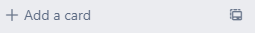
If you click on +Add a card, the template will not be created showing all the tasks
Step 2: Select the template that you want, and a new card will open. Type in the property address and click on "Create Card"
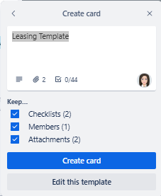

Step 4: The card will then disappear from your page. You will need to clear your filters so that you are viewing all of Magain City Realty’s cards. Scroll down the bottom of the list where you just added a card. You will see your card at the bottom. Click on it and then add yourself as a member. This will now show up in your own list.
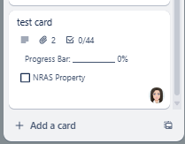

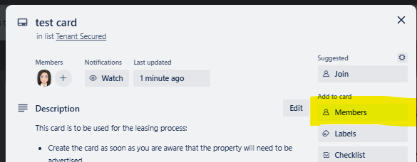

This step is important to ensure that the card appears in your portfolio list
Step 5: Follow all steps under the "Description" to complete all required fields.

