Standard Operating Procedure
Category: General Tasks
Topic: Mail Merge in Property Tree

Step 1: From the tenancy profile, click on the Mail Merge icon under contacts next to the tenants’ details

If you want to send the same template to all tenants at the property, click on “Actions” drop down then select “Mail Merge Multiple” and continue as below.
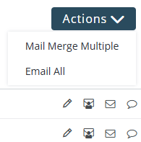

“Select Method” will default to Email
Click on “next”

Step 2: “Select Template” . Click on the drop-down arrow to find the template you wish to use.

If, at this stage, you wish to modify the template in anyway, click on the link
Review the text and adjust as required, then click on

Any documents to attach? Click on , drop the files in and then click on “Attach Files”

Step 3: Click on “Next”
Step 4: Click on “Preview Email” so you can check any changes made and any information required in the merge fields has updated.

At this stage, you can either choose to close the preview or send the preview email to your email inbox.

Step 5: Options to send
- Sending to your email inbox, select

- Sending from Property Tree so the document records in Property Tree against the tenant/owner? Click on 

If you send the email through Property Tree, you will see a record of this under the Communications tab on the tenant profile.

